**The doors of death**

How do we know what’s true?

Introduction:

Professor: We are doing some studies into truth. This is Dave. I pieced him together out of various bits and bobs I found lying around the lab.

Dave will tell you some things and you simply have to determine if he is telling the truth.

What is real?

We can say things about the universe we live in.

Fish can live under water

My wife it beautiful

I’m moving fast

The earth goes round the sun

Killing is wrong

These statements may be true or false. How can we know?

Subjective truths

Some statements are clearly subjective. I think my wife is beautiful, but you may not. We can often rephrase such questions as:

In my opinion, my wife is beautiful and then at least there is a single answer that we can all agree on.

Moral truths

**The senses**

* Sight
* Sound
* Touch

**The senses can be fooled**

(Sensory context)

* Patches are the same shade of grey (the blue/gold dress)
* McGurk Effect!
* Baa Baa Baa… You just heard the man say “Baa Baa Baa”
* Faa Faa, Faa… You just heard the man say “Faa Faa Faa”
* Both videos sound exactly the same

(Distractions)

* The gorilla video: I am going to ask about the number of times the ball is passed by a white player.
* The white player passed the ball 17 times
* Halfway through the video a gorilla came into view and waved at you

[Ultimately our senses are the closest we can get to directly perceiving the world and most of the time they are reliable. However, they can be fooled. However, lets assume for the rest of this test, that your senses are not lying to you.

**Instruments**

We can extend the reach of our senses using instruments. We cannot see other galaxies with the naked eye. But, we understand how a telescope works, so when we look through one at a tiny patch of sky and see this – we can be pretty certain that we are seeing something real.

Similarly when looking through a microsope which allows us to see the very small.

**Logical Reasoning**

Professor:

Dave is tall.

Tall people hit their heads on doorframes more than short people

Dave: I hit my head on doorframes more than most people

Probably true.

Though depends on the truth of my assumptions – is Dave really tall? Do tall people REALLY hit their head more?

These things are probably true because I’ve told them to you – from this you can assume that it is probably true that Dave hits his head more than most people.

We can use this to create statements which are aboslutley true or false. However probably better to say that is is logically valid – to avoid confusion.

S. If Dave is tall and tall people hit their heads more often than most people, then dave hits his head more often than most people.

This is statement taken in its entirety is absolutely true. No probablis about it. Though “truth” of this statement is a statement about its logical validitiy, not about whether Dave really bangs his head.

If all men have exactly two legs and Brian is a man, then Brian has 3 legs.

Completely false.

If all men have exactly two legs and Brian has two legs, then Brian is a man.

[OK, this was a trap – you cannot determine the truth or otherwise of this]

Actually Brian is a bird

If it rains, the trees get wet – therefore If the trees are wet, then it has rained.

If it rains, the trees get wet – the trees are dry, therefore it has not rained.

https://www.youtube.com/watch?v=0F8IDj6I-tM&list=PLS8vfA_ckeuZ9UjAHhA1q-ROZGuE_h21V&index=3

**Language**

Assumption: I saw a man on a hill with a telescope

Statements:

There’s a man on a hill, and I’m watching him with my telescope.

There’s a man on a hill, who I’m seeing, and he has a telescope.

There’s a man, and he’s on a hill that also has a telescope on it.

I’m on a hill, and I saw a man using a telescope.

There’s a man on a hill, and I’m sawing him with a telescope.

Everyday language can be very ambiguous. Even if your statement you want to determine is determinable – you need to make sure you express it unambiguously.

This is why in science we often fall back to mathematics. In maths we can express things completely unambiguously and so ensure that our reasoning is correct.

Five pointed start:

http://gojko.net/2008/08/29/how-many-points-are-there-in-a-five-point-star/

However, we cannot use pure reasoning to figure out if our initial assumptions are correct. Though it has been tried.

Proof for the existence of god:

Ontological argument – Imagine the most greatest being that could be concieved. Then thast being must be a beign which exists for surely ifit did not exist, then ojne could imagine one that is identical to it except for the fact that it exists. So you have just imaged the greatest being that could be conceved and this beign must exist – this being is god.

There is clearly something wrong here – but it is not obvious what.

Well the lanaguge is clearly ambiguous – “Greatest” is very ill defined. It assumes that there even is such a thing as “the greatest” (maybe greatness is like “Standing on the left of” where there may be no single greatest concept. Also there is a linguistic slight of hand – I’ves aid imagine A thing that exists (so therefre that thing exists). I could imagine a unicorn that actually exists – but it doesn’t acutally exist.

Anyway – this is the kind of thing that used to keep philosphers up all night – but if you see something like this is should ring alarm bells.

Scientits often use the language of mathematics to describe their logical reasonsing. Mathematics is completely unambiguous so youre reasoning can be thoroughly checked.

The tradeoff here is that mathematics often ends up being a simplification of what is real. There is a lot so maths associated with squares, triandles and straight lines, but you will never find a perfect example of those in the real world.

So your mathematical reasoning might be flawless, but if the assumptiosn you base it on do not reflect reality then there is no reason to believe your conclusions will either.

Stephen Hawking pointed out that there are all sorts of self consistent universes one could describe with mathematics. But what makes the equeations that describe our one different?

What is it that breathes fire into the equations and makes a universe for them to describe? The usual approach of science of constructing a mathematical model cannot answer the questions of why there should be a universe for the model to describe. Why does the universe go to all the bother of existing?

**Reasoning and assumptions**

I have a hat on my head

I have an apple on my head

Yes I do – it was under the hat.

I have a watermelon on my head

No – But how did you know?

Why is the answer to “I have an apple on my head” I don’t know – but I have a watermelon on my head False?

We have bought in some implicit assumptions and some logical reasoning.

Assumptions:  
1. No watermelon is smaller than that hat

2. If you attempt to put something bigger than the hat under the hat, it would be visible.

Dave: John is standing on my left

John: Sue is standing on my left

Dave; So, Sue is standing on My left

True

Dave: John s standing on my left

John: sue is standing on my left

Sue: Peter is standing on my left

Peter: Belinda is standing on my Left

Back to Dave: Belinda is standing on my left

False – camera looks to the right

Pans back – they are standing in a circle.

There was a hidden assumption here. It was about the behaviour of the “Standing on the left” relationship. It seems reasonable that If A is on the left of B and B is on the left of C then A is on the left of C. This is called transitivity. But in our case it was a false assumption.

In order to use reasoning, we need to be:

1. Sure our logical reasoning is correct
2. Have some faith in our assumptions
3. Be aware of what assumptions we have made

**Faith in assumptions**

How can we have faith in our assumptions?

A common way is to base them on past experience. If something has happened a million times the same way, it seems likely that it will do so again.

The sun will rise tomorrow.

If I stub my toe hard– it will hurt

We can also make inferences from less consistent patterns.

If there are dark clouds in the sky it will probably rain.

However, we need to be careful.

We are very good at seeing patterns. In fact we often see patterns and meaning when there isn’t any.

The stars were originally thought to make shapes in the sky.

We see faces everywhere.

People often read horoscopes and feel they are saying something personal about them

Why does this happen? An evolutionary explanation is that our ancestors evolved on the African savannah where the main dangers would have been lions, crocodiles and other people. With this in mind if you see an ambiguous pattern in the bushes, you are much more likely to survive if you assume it is an animal or other person than assume it is just a random pattern.

Why are we here?

People have asked this since the dawn of time.

But we could mean two different things?

It could mean How did we come to be here? I.e. what were the processes gave rise to our existence.

This is the same sense as we might as “why do earthquakes happen”.

But if we are asking Why in the sense of what is our purpose? Well a purpose really implies some intelligence has a purpose in mind for us. Either that intelligence is us – so we just decide our own purpose or when most people ask this they are probably referring to some other intelligence.

In this case the assumption has been sneaked in by the wording of the question itself.

Some people start from this question and arrive at the conclusion that there is a supernatural being – but this is a case of assuming the thing you are meant to be concluding. It is refered to as “begging the question”.

It seems a natriual question to ask perhaos becahce of our evolutionary tendednc y to see agency in everything (because it is safer to do so).

Confirmation bias

Another issues we face as well as seeigtn pattern evertyehrre is soemthign call confirmation bias. When we have an idea of what is going on we tend to seek out an accept any evidence that backs it up while ignoring or dismissing evidence that contradicts it.

**Truth from authority**

D

**We can test our assumptions**

Give people a random horoscope (50% likely to be there real one and 50% likely to be a random other open) to read and give a score on how well it fits them. Then compare.

But perhaps a few more people DO pic their own horoscope? Does that prove it?

There is a branch of maths called Statistics which deals with this kind of problem very well.

If we have 2231 people taking the test and 52% say it matches well. We can ask:

Suppose there is nothing in horoscopes at all – what is the likelihood if getting this result purely by chance?

It turns out that if there is no truth in horoscopes at all then we would expect to get a result like this around 90% of the time. For a claim to be valid for scientific publication they typically insist that the result should be so significant as 1% chance of it happening by change.

However, there are all sorts of ways to get this wrong and find significance where there isn’t any.

If you repeat the same (failed) experiment 100 times you will probably find one time where your results are significant. Though it is only signifianct if you think of that one run of the experiement in isolation. If you take into account all the other times you ran it, it would only be expected that you get one success in all those attenpts soi a correct analysis would also discard your good result.

However, in practice people do an experiement, find it didn’t’ work – tweak things a bit then do it again. Etc. Eventually it works, they write it up ad publish it. But the only reason it worked is because they did effectively rhe same experiment 100 times and it was a fluke.

**Repetition**

If something only happens once and no evidence remains other than what someone remembers it is hard to draw much from it. There are so many factors that could being errors into the description of what happened:

1. What was actually observed
2. What was rememberd
3. How it is described

And often it is not that

So if you can do an expeiremnt which can be repeated by others, you are in a much better position to assert conclusions from it.

**Models**

A lesser familiar way to discover truth is by constructing models.

A model is a guess of what might be happening (which you perhaps can’t see directly). However, if you can use logical reasoning to make predictions based on your model, you can test them. If your predictions turn out true you can have some faith that your model in some way describes reality.

A monk called Gregor mendel planted peas in the garden of his monestry. A puzzle he has was that if he crossed fertlilised a purple pea plant with a white pea plant the result was not a blend between the two colours but either white or purple.

Try making some plants. Can you figure out what is happening.

Mendels model.

Describe the mendalian genetics model. Show what predictions we would expect.

Example = pick a white pea and purple pea plant.

We don’t know if the purple pea has two purple allials or just one.

If we make a load of offspring, we can see what proportion of whiute and purple children we have.

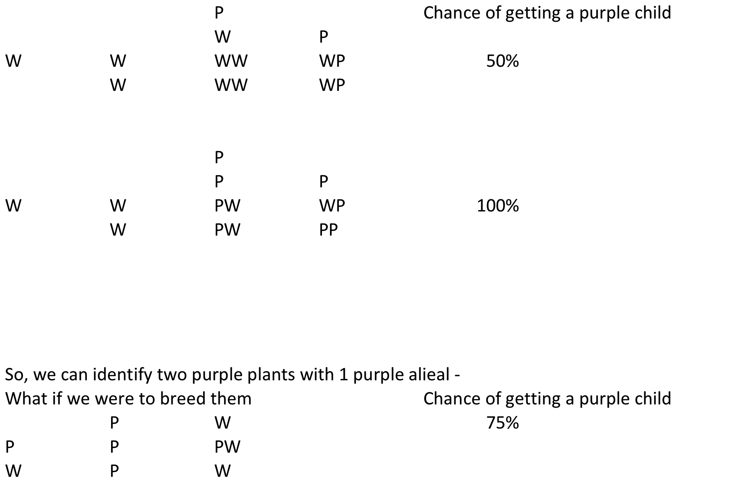

Can we show this as a game? Or sim?

This was all long before we had any idea about DNA or what genes actually were or how the copying mechanism works. It was a hundred years later that two scientists, Watson and Crick discoverdd th strucute of DNA an dhow it copies. The finished off their paper with this no famous sentence:

"It has not escaped our notice that the specific pairing we have postulated immediately suggests a possible copying mechanism for the genetic material."

The sun rising

We use models all the time. Often without realising it. When we observed that the sun will probably rise tomorrow. We observed that it has risen every day for all of recorded history, so we can probably expect it will do so again. But in making this assertion we are applying a model of the sun and the earth along the lines of:

“The earth and the sun tomorrow will be pretty much the same as it has been over the last few thousand years”.

But if we ask “will the sun rise in 2 billion years time?” then that model doesn’t necessarily hold and more and we have to start introducing models of how the stars evolve and change over time.

As far as we know the sun wil rise in 2 billion years time, but it will look much bigger in the sky and each day will last longer.

In 6 billion years the sun will explode and the earth will be destroyed. So the sun will not be rising then.

So we can apply models to help us, but we need to be waring about whether they are appropriate.

Everyone alive now will be dead in 1,000 years time

Here it would be tempting to use the same reasoning as with the sun. As far as we know humans have been around on earth for around 200,000 years. And everyone who was born more than 150 years ago has died.

So surely we will all die too?

There is a significant amount of evidence to bring this into doubt. Our model that the situation in terms of dying for our ancestors is much the same as it is for us is not valid.

There are a large number of people who believe that there are three trends currently happening which will lows us to avoid death.

1. The machines we build are shrinking
2. The fidelity with which we can image and record the inner workings of the human body (and especially the brain) is increasing
3. Our understanding of the algiorithms which run in our breains is improving

It seems possible that these trends will reach a nadir in around 30-40 years time. Where we will be abel to image and record every important aspec of a human’s mind. we are able to construct machiens at a molecular scale (as DNA and our body’s chemical machinery is currently) so we can duplicate and repair any part of the body that is broken and we will understand the algorithms that make us inteligent to the level that we can design better ones.

They call this the singularity. The moment we reach it, we will have tranceded death. We will be abel to repair and impove ourselved indefinielt, maybe even upload ourselves ro a computer for a peried and then put us back into our bodies again – we will be able to make ourselves more intelligent and able than we currently are and the trends that got us to the singulatiry will accelerate. Within a short space of time we will turn all the matter around us into intelligent matter which is an extension of our own intelgence merged with everyone elses – this intelligence will then expand away from us at the speed of light until we are all just part of a giant super-inteligence compising of evertythng in the universe.

Is this really going to happen?

No-one knows, but the prediction is made based on models. Models which we can make intermediate predictions with and so as time goes on we will add evidence for or against this hypothesis.

Tossing a coin

Suppose I have a coin in my pocket and I toss it up 2 times and both time it comes down with a head?

What is it most likely to be next time?

Head,

Tail

Equally likely

What if I did it 19 times and it was ahead each time – what would be the most likely toss then?

Initially we probably had a model that the coin was fair (i.e. it would come down heads and tails with equal likelihood). However, afer 19 tosses, it seems much more likely that our model is wrong and this particular coin is a double headed coin.

How it works vs does it work?

It is worth noting that our model doesn’t have to describe how something works to be usefule. It just has to say something about what we can expect to see from it.

In the case of mendalian inheritance no mechanism was put forward to describe how it work – just what the effect of it was. Indeed with the horoscope experiment, we didn’t need to explain how horoscopes might be succeful to be able to design a useful experience to determine whether it is successful.

If the horoscopes had turned out to be successful, then we could have tried to create more specific models on the mechanism – but there is really no need.

The scientific process

Scientific knowledge advances by people gathering observations, repeating experiments and building models that fit the evidence.

The models are constantly being revised to account for new data. This might imply that pretty much all scientific theories will end up being wrong as they are supplanted by a better model.

However, this is not quite fair.

Originally the romans though that the sun was pulled across the sky by the sun god in a chariot and the other heavenly bodies were moved around in the same way.

The ancient Greeks realised that the patterns were far to regular to really fit the model of inteligent being moving them around and they came up with a complicated set of rules for how they all moved around the earth – which was natural;y at the centre ofthigns.

The Copernicus came along and sia no – the sun is at the centre and all the planets move around that. Suddenyl all these complicated pather became a version simple set of elipses.

Then newton observed that if you drop a ball it drops to the ground. If you throw a ball it goes in an arc and if you through it hard enough it will go round and round the earth in an ellipse. Thus the gravitational explanation for how the planets move was born which fitted the data a little better.

Then einstine described gravity not as a force of 1/r2, but as a warping of space and time around massiver bodies. This gave predictiorns that matched the data even better.

At each stage the model fitted the observations they were able to make and each was a valid modul until the weight of non-fitting observations got too great and then someone came up with a better model.

**Relative truth**

Sometimes thigns which seems like an absulote truth turn out not to be so.

I am on a trail travelling at 40miles an hour sounds like a reasonable “truth” but it rather depends on who is measuring you. For someone on the platform it may be 40mph, but to someone else on the train you are stationary. For someone on Mars you will be trabelling at several thousand mph.

However, once we understand this we can often rephrase the statement to avoid its relitvitiy. E.g. “ I am trabelling at 40mph relative to the platform”.

For most of our existence, we have assumed time to work the same for evertyone. We all age at the same rate and if I observe two things happening at the same time, then you will also observe them happening at the same time.

However, after several expeirements in the 1900s started producing results which did not support eh theorist of the time, Einstein (correctly) proposed the idea that time ran it different speeds depending on how fast you are moving and whether you in a gravitational field.

It turns out that identical twins can be made to age at differnet rates by sending one off in a spaceship for a while. These “relitavistic effects” need to be taken into account by our GPS units which calculating how long it took for signals to reach us from the satellites.

So are any truth really absolute? Or all they all eventually destined to be shown to be relative to you?

It does seem like even though are models change over time, they tend to home in on something. That something seems to be fundamentally true – even if we can not describe it precvisely.

The fact that I can do an experiment and someone else can do it and get exactky rhe same results implies that there is some thread of reality which is the same for all of us and the job of science is to try and describe it as best we can.

Quantum truth

The truth can be wiereder than we might suppose.

Light has been known for a long time to travel in waves.

If you set up this experience the light “fans out” as you see in waves in the sea reaching a harbour wall.

If you have two slits then the waves fan out from both and in some places they cancel out and otherplaces they add up.

If you place a screen here you get an interference pattern.

If you do it with bullets you don’t get the sae effect, you get two ridges fo holes.

If you do it with atoms it behaves like light. Like a wave. You get interference patterns. OK, so maybe atoms are like waves somethow they interact with each other or something to achieve this.

But if you send one atom through at a time you still get this pattern, eachg time the atom is emitted at a specific time and arrives at a specific time in a specific place. But you still get the pattern. If you block one of the slits you dion’t get the pattern.

OK so maybe the atom is splitting in two?

So we place a detector at each slit – and find that the atom is only ever detected at one of them. And also as soon as we do this – no matter what kind of detector we use the interference pattern disappears.

So is each atom going through one slit of two. If it is only going through one, then how could the addition of another slit cause atoms to not land in the dark patches of the interference pattern.

If they are splitting in two, surely we should be able to detect them at either slit. And what’s more we ought to be abel to detect them and still see the interferenfce pattern.

We can go a stage further. If we replace the screen with detector that can detect what direction the atom came from, then these detectors can tell us which slit the atoms came through. Putting that detector there destroys the interference pattern.

So to ask somethine as simple as “which way did this particle travel to get here in the past” turns out that it is dependent on how we measure it in the present.

In some sense we could argue that none of the universes’s history actually exists in any kind of concrete form until we attempt to measure its effect now. So maybe different beigns with different brains and different instruments would construct a completely different model of the universe. Maybe one that only has two dinemsions instead of 3?

However, even in the midst of this extreme relativity it seems that some thigns are still universally true – we just need to figure out what they are.

Later

Magic tricks (wilfully use all of these)

Confirmation bias

What is the purpose of the universe?

Studies have shown that juries give a lot of weight to eye-witness testimony.

The reason for this is that we don’t store what our senses tell us like a video record. Instead we have a mental model of the world around us which is informed by the evidence of our senses.